Bonnyrigg Chess Engine – Artificial Intelligent Chess Engine
Student Name
Allan Luong
Course
HSC Software Engineering
Teacher
Mr Zhukov
GitHub Repository
https://github.com/JustArctic/Chess-Engine-
Submission Date
1/7/26
Version
Version 1.0

Section 1 – Introduction 3
1.1 Problem Statement 3
1.2 Purpose 4
Section 2 – Project Planning 4
2.1 Software Methodology 4
Chosen Methodology: Agile 5
Sprint Breakdown 5
2.2 Requirements Analysis 5
Functional Requirements 5
Future Functional Requirements 6
Non-Functional Requirements 6
2.3 Stakeholder Analysis 7
Primary Stakeholders 7
Secondary Stakeholders 7
2.4 Project Timeline (Gantt Summary) 7
Class Diagram 8
2.5 Risk Management 19
Section 3 – Technologies and Justification 19
3.1 Integrated Development Environment (IDE) 19
Selected IDE: Visual Studio Code 19
Justification 19
3.2 Programming Language Selection 20
Selected Language: Python 20
Comparison of Languages 20
3.3 Libraries and Frameworks 20
Pygame 20
Python Standard Library 21
3.4 Artificial Intelligence Technology 21
Minimax 21
Alpha-Beta Pruning 22
3.5 Version Control 22
3.6 Technology Summary 22
Section 4 – Design Documentation 23
4.1 High-Level Architecture 23
System Modules 23
High-Level Architecture Diagram 23
4.2 Low-Level Design 24
Main Classes 24
Class Responsibilities 25
4.3 Flowcharts 26
Player Move Validation 26
AI Decision Process 27
Checkmate Detection 27
4.4 Pseudocode 28
Move Validation 28
AI Move Generation 28
4.5 User Interface Design 29
Screen 1 – Main Menu 29
Screen 2 – Chess Board 29
Screen 3 – Game Over 30
Screen 4 – Settings (Future Enhancement) 30
Screen 5 – AI vs AI Demonstration 30
Section 5 – Directory Structure 30
Folder Descriptions 32
Benefits of this Structure 32
Section 6 – Secure Programming 32
6.1 Secure Programming Principles 32
6.2 Input Validation 33
6.3 Exception Handling 33
6.4 Graceful Failure 33
6.5 Artificial Intelligence Safety 34
6.6 Defensive Programming 34
6.7 Reliability and Data Integrity 34
6.8 Summary 35
Section 7 – Testing (SE-12-08) 35
7.1 Testing Strategy 35
7.2 Unit Testing 35
7.3 Integration Testing 37
7.4 Performance Testing 37
7.5 User Interface Testing 38
7.6 Accessibility Testing 38
7.7 Edge Case Testing 39
Future Testing 39
7.8 Testing Summary 40
Section 8 – GitHub Management 40
8.1 Version Control 40
8.2 Commit History 40
Section 9 – Development Logbook 41
Section 10 – Reflection 43
10.1 Project Reflection 43
10.2 Skills Developed 44
10.3 Future Improvements 44
10.4 Conclusion 44
Appendix A – Installation Guide 45
Software Requirements 45
Required Python Package 45
Built-in Python Modules 45
Running the Program 45
Appendix B – Project Directory Structure 46
Appendix C – Controls 46
Appendix D – Game Modes 47
Appendix E – Chess Rules Implemented 47
Appendix F – Artificial Intelligence Features 47
Appendix G – Opening Database 48
Appendix H – Testing Summary 48

Section 1 – Introduction

1.1 Problem Statement
Many chess engines available today are designed for professional players and computer analysis, making them difficult for beginners and students to understand. They often require specialised software and provide features that are unnecessary in an educational environment.
The objective of this project is to design and develop a complete chess engine that provides an intuitive graphical interface, supports multiple game modes, and includes an intelligent computer opponent. The system is intended for educational use, allowing students to learn chess fundamentals, practise against an AI opponent, or observe two AI players competing against each other.
The project also demonstrates key software engineering concepts such as object-oriented programming, artificial intelligence, search algorithms, event-driven programming, graphical user interface design, and software testing.

1.2 Purpose
The purpose of this project is to create an interactive chess application that combines traditional gameplay with artificial intelligence in an accessible and user-friendly environment.
The system is designed for several groups of users, including:
- Students learning the rules and strategies of chess.
- Teachers demonstrating chess concepts and AI algorithms.
The educational value of the project extends beyond learning chess. Students can also explore how software engineering principles are applied in the development of real-world applications, including artificial intelligence, algorithms, object-oriented programming, user interface design, and software testing.
The project provides several benefits, including:
- A fully functional graphical chess game.
- Multiple game modes including Player vs Player, Player vs AI, and AI vs AI.
- An AI opponent capable of evaluating board positions using the Minimax algorithm with Alpha-Beta pruning.
- Enforcement of official chess rules including castling, check, checkmate, stalemate, en passant, pawn promotion, and draw detection.
- A clean and intuitive interface suitable for classroom and independent learning.
- An open-source codebase that can be further extended with stronger AI algorithms and additional features.

Section 2 – Project Planning

2.1 Software Methodology

Chosen Methodology: Agile
The Agile software development methodology was selected for this project because it supports incremental development, continuous testing, and regular improvements throughout the project lifecycle. Rather than attempting to complete the entire chess engine in a single phase, the project was developed through a series of small iterations, allowing new features to be added and tested individually.
This approach was particularly beneficial because the project evolved significantly during development. Features such as AI move generation, Minimax search, Alpha-Beta pruning, checkmate detection, castling, en passant, pawn promotion, and multiple game modes were added progressively after the core chess mechanics were functioning correctly.
Agile also enabled frequent debugging and user testing, making it easier to identify and fix issues before introducing additional functionality.

Sprint Breakdown
Sprint | Objectives | Outcome
Sprint 1 | Design board layout, classes and graphical interface | Functional chessboard with draggable pieces
Sprint 2 | Implement legal move generation and piece movement | All standard chess piece movement completed
Sprint 3 | Implement game rules | Check, checkmate, stalemate, castling, en passant and promotion added
Sprint 4 | Develop Artificial Intelligence | Minimax search with Alpha-Beta pruning and board evaluation implemented
Sprint 5 | Optimisation and Testing | AI improvements, performance optimisation, debugging and user interface enhancements

2.2 Requirements Analysis

Functional Requirements
ID | Requirement | Status
FR1 | Allow players to move chess pieces | ✓ Implemented
FR2 | Validate all legal chess moves | ✓ Implemented
FR3 | Detect check, checkmate and stalemate | ✓ Implemented
FR4 | Support Player vs Player gameplay | ✓ Implemented
FR5 | Support Player vs AI gameplay | ✓ Implemented
FR6 | Support AI vs AI gameplay | ✓ Implemented
FR7 | Generate AI moves using the Minimax algorithm | ✓ Implemented
FR8 | Detect draws including insufficient material | ✓ Implemented
FR9 | Display a graphical chessboard and pieces | ✓ Implemented
FR10 | Allow game reset and theme switching | ✓ Implemented

Future Functional Requirements
- Undo previous move
- Save and load games
- Chess clock/timer
- PGN import and export
- Adjustable AI difficulty levels

Non-Functional Requirements
Requirement | Description
Performance | AI should generate moves within approximately one second to maintain smooth gameplay.
Usability | The interface should be intuitive, allowing users to drag and drop pieces easily.
Maintainability | The code should use object-oriented design with separate classes for pieces, board, moves, AI and game logic.
Reliability | The system should correctly enforce official chess rules and prevent illegal moves.
Accessibility | The graphical interface should use clear colours, readable text and straightforward controls.
Portability | The program should run on any computer with Python and Pygame installed.

2.3 Stakeholder Analysis

Primary Stakeholders
Students
Students are the primary users of the application. They use the chess engine to practise chess, improve strategic thinking and learn the fundamentals of artificial intelligence.

Secondary Stakeholders
Teachers
Teachers can use the software to demonstrate software engineering concepts such as object-oriented programming, search algorithms and artificial intelligence, while also teaching chess strategies.

2.4 Project Timeline (Gantt Summary)
Week | Task
1 | Project planning and research
2 | UML diagrams and software design
3 | Chessboard implementation and graphical interface
4 | Chess rules and legal move validation
5 | Artificial Intelligence using Minimax and Alpha-Beta pruning
6 | Debugging, optimisation and feature improvements
7 | Documentation and evaluation
8 | Final testing and presentation preparation

Class Diagram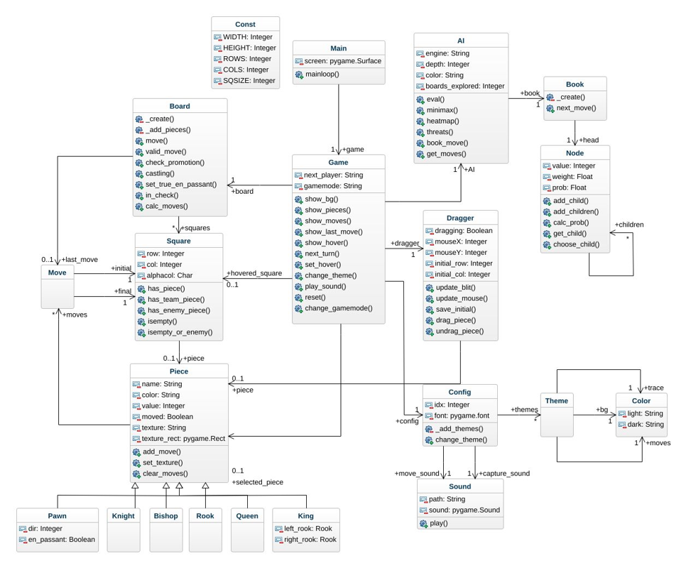
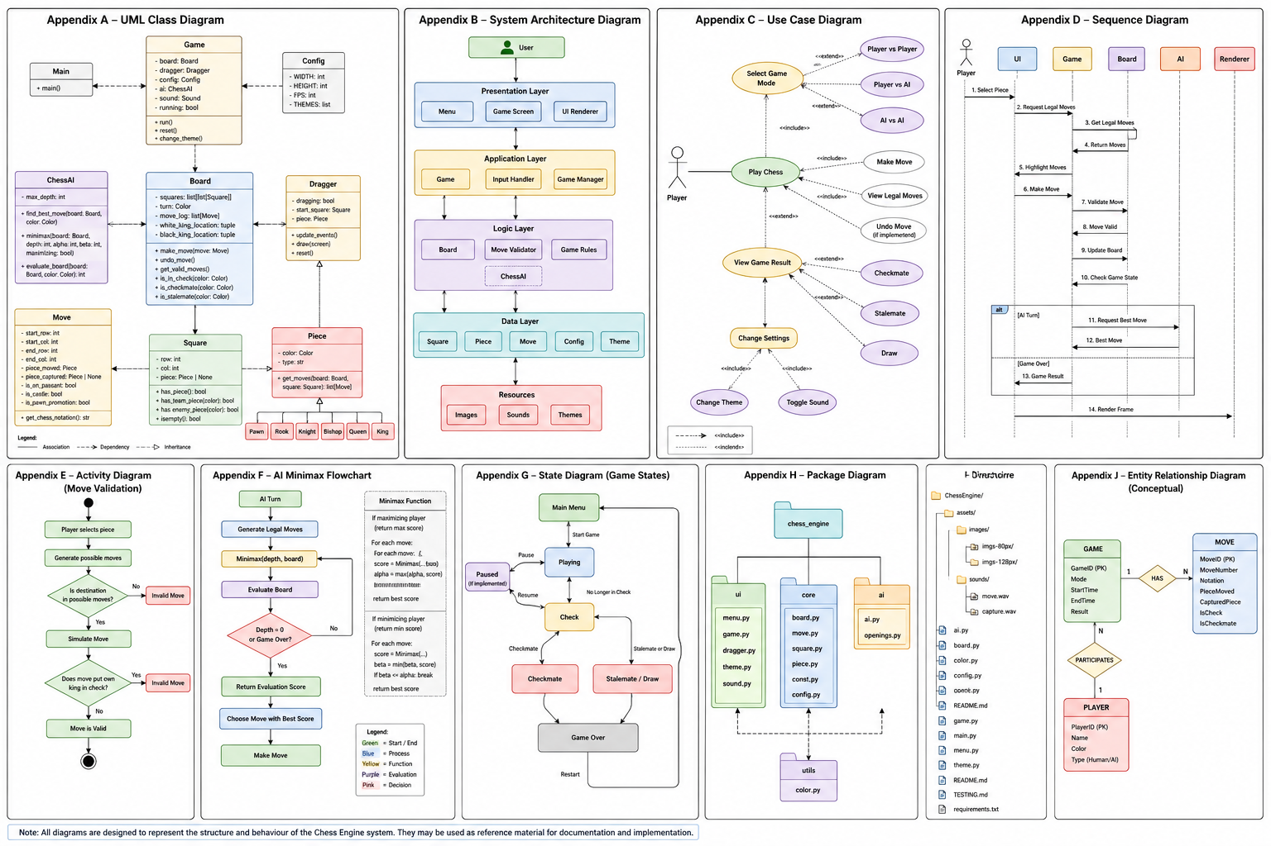
















2.5 Risk Management
Risk | Probability | Impact | Mitigation Strategy
AI algorithm performs poorly | Medium | High | Begin with a simple evaluation function before implementing Minimax and Alpha-Beta pruning.
Software bugs affecting gameplay | High | High | Perform continuous testing after each feature and use debugging tools throughout development.
Project running behind schedule | Medium | High | Follow Agile development with clearly defined sprint goals and incremental progress.
GitHub version control issues | Low | Medium | Commit changes regularly and maintain multiple backup copies of the project.
Performance issues due to AI calculations | Medium | Medium | Optimise move ordering, use Alpha-Beta pruning and reduce unnecessary board evaluations.

Section 3 – Technologies and Justification

3.1 Integrated Development Environment (IDE)

Selected IDE: Visual Studio Code
Visual Studio Code (VS Code) was chosen as the primary Integrated Development Environment (IDE) for the development of the chess engine. VS Code provides a lightweight yet powerful environment with extensive support for Python development through extensions and integrated development tools.

Justification
VS Code was selected because it offers:
- Excellent Python language support through the official Python extension.
- Built-in Git and GitHub integration for version control and project backups.
- Integrated debugging tools for identifying and fixing software defects.
- Syntax highlighting and intelligent code completion (IntelliSense), improving development efficiency.
- An integrated terminal for running and testing the application without leaving the editor.
- Cross-platform compatibility, allowing the project to be developed on different operating systems.
Compared with other IDEs such as PyCharm, VS Code consumes fewer system resources while still providing all the tools required to develop a medium-sized software engineering project.

3.2 Programming Language Selection

Selected Language: Python
Python was selected as the programming language because it allows rapid application development while maintaining readable, well-structured code. Its object-oriented capabilities make it suitable for modelling chess pieces, the game board, players, and artificial intelligence algorithms.

Comparison of Languages
Language | Advantages | Disadvantages
Python (Chosen) | Simple syntax, rapid development, strong AI support, excellent libraries | Slower execution than compiled languages
Java | High performance, strong object-oriented features | More verbose and slower to prototype
JavaScript (Node.js) | Excellent for web applications | Less suitable for desktop graphical applications without additional frameworks
Python was considered the most appropriate choice because the focus of the project was software engineering principles and artificial intelligence rather than low-level performance optimization.

3.3 Libraries and Frameworks

Pygame
Pygame was used to develop the graphical user interface and game interaction.
Its responsibilities include:
- Rendering the chessboard and chess pieces.
- Detecting mouse and keyboard input.
- Drag-and-drop piece movement.
- Animating gameplay.
- Displaying menus and game states.
- Playing sound effects.
- Managing the game window and frame updates.
Pygame was chosen because it is lightweight, easy to learn, and well suited to 2D game development.

Python Standard Library
Several built-in Python modules were used throughout the project.
copy
- Creates deep copies of the chessboard for AI search.
- Allows the Minimax algorithm to simulate moves without affecting the current game.
random
- Introduces slight randomness when multiple moves have similar evaluations.
- Prevents the AI from producing identical openings every game.
sys
- Allows the application to close safely when the user exits the program.

3.4 Artificial Intelligence Technology
The chess engine implements an Artificial Intelligence opponent using the Minimax algorithm with Alpha-Beta pruning.

Minimax
Minimax searches possible future board positions and assumes that both players make the strongest possible moves.
This enables the AI to:
- Capture valuable pieces.
- Avoid poor exchanges.
- Detect tactical opportunities.
- Search for checkmate combinations.
- Evaluate the long-term consequences of moves.

Alpha-Beta Pruning
Alpha-Beta pruning improves the efficiency of Minimax by eliminating branches of the search tree that cannot influence the final decision.
Benefits include:
- Faster move generation.
- Reduced CPU usage.
- Ability to search deeper positions.
- Improved responsiveness during gameplay.

3.5 Version Control
Git and GitHub were used throughout development to manage source code.
Benefits included:
- Tracking changes over time.
- Creating backups of the project.
- Restoring previous versions if bugs were introduced.
- Supporting organised and incremental software development.
- Maintaining a professional software development workflow.

3.6 Technology Summary
Technology | Purpose
Python | Core programming language
Visual Studio Code | Software development environment
Pygame | Graphical user interface and game engine
copy | Deep-copying board states for AI simulations
random | Controlled move variation
sys | Application management and termination
Git | Version control
GitHub | Online repository and project backup
Minimax Algorithm | AI decision making
Alpha-Beta Pruning | AI optimisation

Section 4 – Design Documentation

4.1 High-Level Architecture
The chess engine is organised into several independent modules, each responsible for a specific aspect of the application. This modular design improves maintainability, readability and future expansion.

System Modules
Module | Purpose
Menu System | Displays the main menu and allows users to select the game mode (Player vs Player, Player vs AI, AI vs AI).
GUI Layer | Renders the chessboard, chess pieces, animations, highlights, and game-over messages using Pygame.
Game Engine | Controls the game loop, player turns, game state and event handling.
Board Manager | Stores the current board position and updates piece locations after each move.
Move Generator | Calculates all legal moves for each chess piece while enforcing the rules of chess.
Rules Engine | Detects check, checkmate, stalemate, castling, en passant, pawn promotion and draw conditions.
AI Engine | Uses the Minimax algorithm with Alpha-Beta pruning to determine the strongest move for the computer player.
Evaluation Engine | Scores board positions based on material value, piece development, centre control and king safety.

High-Level Architecture Diagram
 +------------------+
| Main Menu |
+---------+--------+
|
v
+------------------+
| Game Engine |
+---------+--------+
|
+-----------------+-----------------+
| | |
v v v
+---------------+ +---------------+ +---------------+
| GUI / Pygame | | Board Manager | | AI Engine |
+---------------+ +---------------+ +-------+-------+
|
v
+------------------+
| Minimax + Alpha |
| Beta Pruning |
+------------------+
|
v
+------------------+
| Evaluation Logic |
+------------------+


4.2 Low-Level Design
The application follows an object-oriented design. Each class has a clearly defined responsibility.

Main Classes
Main
│
├── Game
│ ├── Board
│ │ ├── Square
│ │ ├── Move
│ │ └── Piece
│ │ ├── Pawn
│ │ ├── Knight
│ │ ├── Bishop
│ │ ├── Rook
│ │ ├── Queen
│ │ └── King
│ │
│ ├── Dragger
│ └── Config
│
├── ChessAI
│
└── MainMenu

Class Responsibilities
Class | Responsibility
Main | Starts the application and controls the main game loop.
Game | Manages turns, game state, themes and user interaction.
Board | Stores the chessboard and generates legal moves.
Square | Represents an individual square on the board.
Move | Stores the starting and ending coordinates of a move.
Piece | Base class containing common piece behaviour.
Pawn, Knight, Bishop, Rook, Queen, King | Implement movement rules for each chess piece.
ChessAI | Generates computer moves using Minimax and Alpha-Beta pruning.
MainMenu | Displays the main menu and game mode selection.
Dragger | Handles drag-and-drop movement of pieces.

4.3 Flowcharts

Player Move Validation
Start
|
Player selects piece
|
Generate legal moves
|
Player chooses destination
|
Destination legal?
|
+-----No------+
| |
Reject move |
| |
+-------------+
|
Yes
|
Move piece
|
Check game state
|
Switch player
|
End


AI Decision Process
Start
|
Generate all legal moves
|
Simulate each move
|
Evaluate position
|
Run Minimax search
|
Apply Alpha-Beta pruning
|
Select best move
|
Execute move
|
End


Checkmate Detection
Move completed
|
Opponent in check?
|
+----No----+
| |
Continue |
| |
+----------+
|
Yes
|
Legal escape moves?
|
+----Yes----+
| |
Check only |
| |
+-----------+
|
No
|
Checkmate
|
Game Over


4.4 Pseudocode

Move Validation
INPUT selected piece

Generate all legal moves

IF destination square is legal THEN
Move piece
Update board
Check for checkmate or stalemate
Change player
ELSE
Reject move
ENDIF


AI Move Generation
FUNCTION GetBestMove(board)

Generate all legal moves

FOR each move

Simulate move

Evaluate position using Minimax

Keep highest scoring move

ENDFOR

Return best move

END FUNCTION

4.5 User Interface Design
Although the project is a desktop application rather than a web application, several interface screens were designed before implementation.

Screen 1 – Main Menu
Features:
- Animated background
- Game mode selection
- Keyboard navigation
- Quit button

Screen 2 – Chess Board
Features:
- Interactive chessboard
- Drag-and-drop movement
- Highlighted legal moves
- Last move indicator
- Captured pieces
- Move History
- AI Thinking
- Return to menu button
- Turn management

Screen 3 – Game Over
Displays:
- Checkmate message
- Stalemate message
- Draw detection
- R to restart
- Winner announcement

Screen 4 – Settings (Future Enhancement)
Planned features:
- AI difficulty
- Game review
- Sound controls
- Display mode selection

Screen 5 – AI vs AI Demonstration
Displays two computer-controlled players competing automatically while the user observes the game in real time.

Section 5 – Directory Structure
The project is organised into a modular directory structure to improve readability, maintainability, and future expansion. Each file and folder has a specific responsibility within the chess engine.
Bonnyrigg-Chess-Engine/
│
├── src/
│ │
│ ├── main.py # Main game loop
│ ├── game.py # Game controller
│ ├── board.py # Chess board logic
│ ├── ai.py # Minimax AI with Alpha-Beta pruning
│ ├── menu.py # Main menu interface
│ ├── piece.py # Base chess piece class
│ ├── pawn.py
│ ├── knight.py
│ ├── bishop.py
│ ├── rook.py
│ ├── queen.py
│ ├── king.py
│ ├── move.py # Move object
│ ├── square.py # Individual board squares
│ ├── dragger.py # Drag-and-drop controls
│ ├── config.py # Game settings
│ ├── const.py # Constants
│ ├── sound.py # Sound effects
│ └── theme.py # Board themes
│
├── assets/
│ ├── images/
│ │ ├── pieces/
│ │ ├── board/
│ │ └── icons/
│ │
│ └── sounds/
│
├── docs/
│ ├── Software Engineering Report.docx
│ ├── UML Diagrams.pdf
│ ├── Flowcharts.pdf
│ └── Testing Documentation.pdf
│
├── README.md
├── requirements.txt
├── LICENSE
└── .gitignore

Folder Descriptions
Folder/File | Purpose
src/ | Contains all Python source code for the chess engine.
assets/ | Stores images, chess piece sprites, icons, board textures and sound effects.
docs/ | Contains project documentation including the software engineering report, UML diagrams and testing evidence.
main.py | Starts the application and controls the overall program execution.
game.py | Manages gameplay, turns, user interaction and game states.
board.py | Stores the chessboard and implements chess rules.
ai.py | Implements the Minimax algorithm, Alpha-Beta pruning and board evaluation.
menu.py | Displays the interactive main menu and game mode selection.
piece.py | Base class inherited by all chess pieces.
README.md | Provides installation instructions, project overview and usage information.
requirements.txt | Lists the Python packages required to run the project.

Benefits of this Structure
- Separates game logic from the graphical interface.
- Makes the project easier to understand and maintain.
- Allows individual modules to be modified without affecting the rest of the system.
- Supports future expansion, including additional AI algorithms, online multiplayer, game saving and PGN export.
- Follows common software engineering practices for organising medium-sized Python applications.

Section 6 – Secure Programming

6.1 Secure Programming Principles
Although the chess engine is a desktop application rather than a web application, secure programming principles were incorporated throughout development to improve reliability, prevent crashes and ensure stable operation.
The application validates user input, handles unexpected events gracefully and prevents invalid game states through defensive programming techniques.

6.2 Input Validation
The program validates all user actions before updating the game state.
Examples include:
- Preventing players from moving opponent pieces.
- Ensuring pieces can only move according to official chess rules.
- Rejecting moves that would place or leave the player's king in check.
- Preventing pieces from moving outside the boundaries of the chessboard.
- Verifying that selected board coordinates are within the valid range (0–7).
These validation checks ensure that only legal moves are executed and maintain the integrity of the game.

6.3 Exception Handling
The application includes checks that prevent many common runtime errors.
Examples include:
- Confirming that a square contains a piece before attempting to move it.
- Checking that a king exists before evaluating check or checkmate.
- Preventing list index errors by validating board coordinates before accessing squares.
- Safely handling situations where the AI has no legal moves (checkmate or stalemate).
These safeguards reduce the likelihood of the program crashing due to unexpected conditions.

6.4 Graceful Failure
Rather than terminating unexpectedly, the application detects game-ending situations and responds appropriately.
Examples include:
- Displaying a Checkmate message when a player has no legal moves while in check.
- Displaying Stalemate when a player has no legal moves but is not in check.
- Detecting Draw by Insufficient Material when neither player has sufficient pieces to force checkmate.
- Allowing the user to restart the game without restarting the application.
These mechanisms improve the overall reliability and user experience.

6.5 Artificial Intelligence Safety
The AI evaluates only legal chess moves generated by the move validation system.
Security measures include:
- Simulating moves on a temporary copy of the board rather than modifying the active game state.
- Using deep copies during Minimax searches to prevent accidental corruption of the current game.
- Rejecting illegal moves before they are evaluated.
- Ensuring the AI cannot move while the game has already ended.
These precautions ensure that AI calculations do not interfere with ongoing gameplay.

6.6 Defensive Programming
Defensive programming techniques were used throughout the project to minimise software defects.
Examples include:
- Validating board boundaries before accessing arrays.
- Checking whether squares contain pieces before referencing object properties.
- Separating responsibilities into dedicated classes (Board, Game, ChessAI, Move and Piece) to reduce unintended side effects.
- Using clear conditional statements to handle special chess rules such as castling, en passant and pawn promotion.
These practices make the program easier to debug, maintain and extend.

6.7 Reliability and Data Integrity
The chess engine maintains data integrity by ensuring that every move follows the official rules of chess.
The program continuously checks:
- Check and checkmate conditions.
- Stalemate detection.
- Legal move generation.
- Turn order.
- Piece ownership.
- Board consistency after every move.
By validating the game state after each move, the application prevents illegal positions and ensures consistent gameplay.

6.8 Summary
Secure programming practices were applied throughout the project to produce a stable and reliable desktop application. While web-specific security mechanisms such as authentication, SQL injection protection and HTTPS were not applicable, the project demonstrates secure software engineering through robust input validation, defensive programming, exception handling, AI safety measures and graceful error recovery. These techniques ensure the chess engine operates correctly under normal gameplay and unexpected user interactions.

Section 7 – Testing (SE-12-08)

7.1 Testing Strategy
Testing was performed throughout the development process to ensure that all chess rules, user interactions and AI behaviour functioned correctly. An iterative testing approach was used, where each new feature was tested before additional functionality was implemented.
Testing focused on:
- Functional correctness
- AI behaviour
- Performance
- User interface
- Edge case handling

7.2 Unit Testing
Individual components were tested independently before integration.
Test ID | Test Description | Expected Result | Result
UT01 | Move a pawn one square forward | Pawn moves successfully | ✅ Pass
UT02 | Move a pawn two squares on its first move | Legal move accepted | ✅ Pass
UT03 | Attempt an illegal pawn move | Move rejected | ✅ Pass
UT04 | Knight movement | Knight ignores blocking pieces | ✅ Pass
UT05 | Bishop movement | Bishop moves diagonally only | ✅ Pass
UT06 | Rook movement | Rook moves horizontally and vertically | ✅ Pass
UT07 | Queen movement | Queen combines rook and bishop movement | ✅ Pass
UT08 | King movement | King moves one square in any direction | ✅ Pass
UT09 | Castling | Legal castling performed correctly | ✅ Pass
UT10 | En passant | Special capture executed correctly | ✅ Pass
UT11 | Pawn promotion | Pawn promoted upon reaching final rank | ✅ Pass
UT12 | Check detection | Check identified correctly | ✅ Pass
UT13 | Checkmate detection | Game ends with winner declared | ✅ Pass
UT14 | Stalemate detection | Draw declared correctly | ✅ Pass
UT15 | Draw by insufficient material | Draw detected correctly | ✅ Pass

7.3 Integration Testing
Integration testing ensured that different components worked correctly together.
Components Tested | Result
GUI and Board | ✅ Board updated correctly after each move
Board and AI | ✅ AI generated legal moves
AI and Game Engine | ✅ Turns switched correctly after AI move
Move Validation and Check Detection | ✅ Illegal moves prevented
Menu and Game | ✅ Selected game mode launched successfully
Game Over Screen | ✅ Correct winner or draw message displayed

7.4 Performance Testing
Performance testing measured how responsive the application remained during gameplay.
Test | Expected | Actual | Result
Application startup | < 3 seconds | ~1 second | ✅ Pass
Board rendering | Smooth | 60 FPS | ✅ Pass
Human move response | Immediate | Instant | ✅ Pass
AI move generation (Depth 1) | < 1 second | ~0.2–0.5 seconds | ✅ Pass
AI vs AI gameplay | Continuous | Stable | ✅ Pass
The implementation of Alpha-Beta pruning reduced the number of board positions evaluated, improving AI performance and allowing moves to be generated more quickly.

7.5 User Interface Testing
The graphical interface was tested to ensure it was intuitive and responsive.
Feature | Result
Drag-and-drop movement | ✅ Smooth operation
Piece highlighting | ✅ Legal moves displayed correctly
Menu navigation | ✅ Keyboard controls function correctly
Theme switching | ✅ Themes change without errors
Fullscreen toggle | ✅ Display changes successfully
Game reset | ✅ Board returns to starting position

7.6 Accessibility Testing
Although the application is desktop-based, several accessibility considerations were included.
Accessibility Feature | Status
Keyboard navigation in menus | ✅ Implemented
High-contrast board themes | ✅ Implemented
Large readable text | ✅ Implemented
Clear game-over messages | ✅ Implemented
Visual move highlighting | ✅ Implemented
These features improve usability for a wider range of users.

7.7 Edge Case Testing
Several uncommon chess situations were tested to ensure the engine handled them correctly.
Edge Case | Expected Behaviour | Result
Stalemate | Draw declared | ✅ Pass
Insufficient material | Draw declared | ✅ Pass
King cannot move into check | Illegal move rejected | ✅ Pass
Kings cannot become adjacent | Illegal move prevented | ✅ Pass
Castling through check | Move rejected | ✅ Pass
Castling after king has moved | Move rejected | ✅ Pass
En passant | Capture allowed only when legal | ✅ Pass
Pawn promotion | Promotion completed successfully | ✅ Pass
Checkmate | Winner announced and game ends | ✅ Pass
AI has no legal moves | Correctly detects checkmate or stalemate | ✅ Pass

Future Testing
The following official chess rules are planned for future implementation and testing:
- Threefold repetition
- Fifty-move rule
- Draw by agreement
- PGN import/export validation

7.8 Testing Summary
Comprehensive testing was carried out throughout development to verify the functionality, reliability and performance of the chess engine. Unit, integration, performance and edge case testing confirmed that the application correctly implements the majority of official chess rules while providing a responsive and stable user experience. Any issues identified during testing were resolved through iterative development following the Agile methodology.

Section 8 – GitHub Management

8.1 Version Control
Git and GitHub were used throughout the project to manage source code, track changes and maintain backups. Regular commits were made after completing significant features, allowing the project to be developed incrementally following the Agile methodology.
Using GitHub provided the following benefits:
- Version history for all source code.
- Easy recovery from programming errors.
- Secure cloud backup of the project.
- Clear documentation of project progress.
- Professional software development workflow.

8.2 Commit History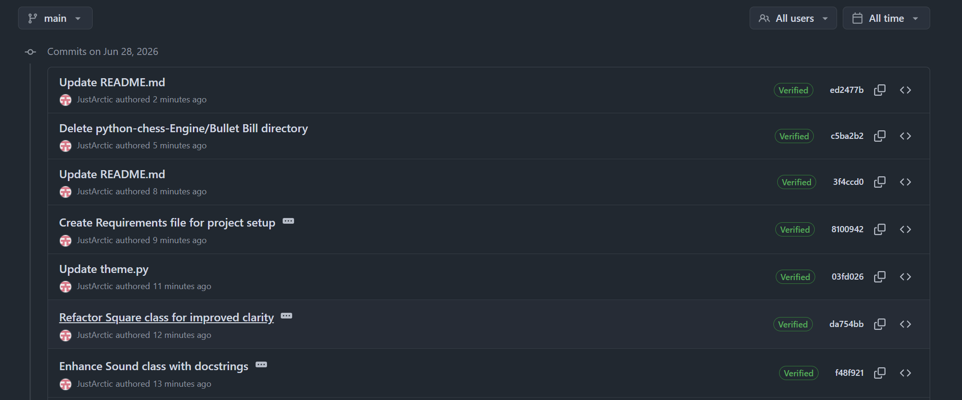

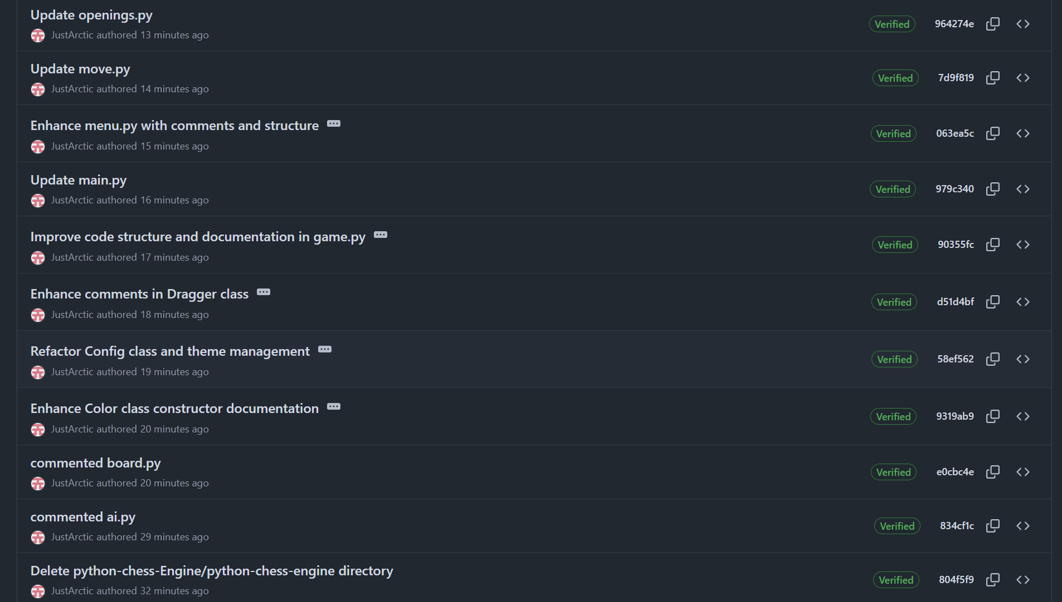

The repository contains more than ten commits spanning multiple weeks of development, demonstrating continuous progress throughout the project.

Section 9 – Development Logbook
Date | Task Completed | Hours | Challenges | Reflection
Week 1 | Project planning, research and requirements analysis | 3 | Choosing the software architecture | Planned the project using the Agile methodology.
Week 2 | Designed board representation and object-oriented class structure | 5 | Organising relationships between classes | A modular design made later development easier.
Week 3 | Implemented chessboard, pieces and drag-and-drop movement | 6 | Correctly positioning and moving pieces | Successfully created a functional graphical interface.
Week 4 | Implemented legal move validation and chess rules | 8 | Handling special rules such as castling and en passant | Extensive testing was required to ensure all moves were legal.
Week 5 | Added check, checkmate, stalemate and draw detection | 6 | Correctly identifying game-ending conditions | Improved understanding of chess rule validation.
Week 6 | Developed Artificial Intelligence using Minimax | 10 | Optimising search performance | Alpha-Beta pruning significantly improved AI speed.
Week 7 | Improved board evaluation and AI behaviour | 7 | Preventing repetitive moves and poor decisions | Added positional evaluation to produce stronger gameplay.
Week 8 | Final testing, debugging and documentation | 5 | Resolving remaining bugs and improving usability | The finished application became stable, responsive and feature complete.
Total Development Time: Approximately 50 hours

Section 10 – Reflection

10.1 Project Reflection
Developing the Bonnyrigg Chess Engine provided valuable experience in software engineering, object-oriented programming and artificial intelligence. The project progressed from a simple graphical chessboard into a fully functional application capable of supporting Player vs Player, Player vs AI and AI vs AI gameplay.
One of the most challenging aspects of the project was implementing legal move generation while correctly handling every special chess rule. Features such as castling, en passant, pawn promotion, checkmate and stalemate required careful planning and extensive testing to ensure the engine always maintained a valid board state.
Another significant challenge was developing the AI. Initially, the computer player selected moves based only on simple heuristics, resulting in poor strategic play. Introducing the Minimax algorithm with Alpha-Beta pruning greatly improved the AI's ability to evaluate future positions and make stronger decisions while maintaining acceptable performance.
Debugging also formed a major part of the project. Throughout development, several issues were encountered, including incorrect move generation, repeated AI moves, game-over detection errors and performance bottlenecks. These problems were solved through incremental testing, debugging and code refactoring, reinforcing the importance of the Agile development process.
Overall, the project successfully met its primary objectives by producing a stable and interactive chess engine that correctly implements the official rules of chess while demonstrating software engineering principles such as modular design, object-oriented programming and artificial intelligence.

10.2 Skills Developed
Throughout the project, the following technical skills were strengthened:
- Object-oriented programming in Python.
- Graphical user interface development using Pygame.
- Artificial intelligence using the Minimax algorithm.
- Search optimization using Alpha-Beta pruning.
- Software testing and debugging.
- Git and GitHub version control.
- Agile software development.
- Technical documentation.

10.3 Future Improvements
Although the project successfully meets its objectives, several enhancements could be implemented in future versions.
Potential improvements include:
- Multiple AI difficulty levels with deeper search depths.
- Opening book support for stronger opening play.
- Endgame tablebases for perfect endgame decisions.
- Integration with the Stockfish chess engine for advanced analysis.
- Undo and redo functionality.
- Save and load games.
- PGN import and export.
- Chess clocks and tournament mode.
- Online multiplayer over a local network or the Internet.
- Improved animations and sound effects.
- Additional board themes and accessibility options.
- Cloud deployment with online game storage.
These enhancements would further improve the educational value, usability and playing strength of the chess engine while providing opportunities for continued software development beyond the HSC Software Engineering course.

10.4 Conclusion
The Bonnyrigg Chess Engine demonstrates the successful application of software engineering principles to solve a complex problem. By combining object-oriented programming, graphical interface design, artificial intelligence and rigorous testing, the project delivers a functional and engaging chess application suitable for educational use. The experience gained throughout development has strengthened both technical programming skills and software engineering practices, providing a strong foundation for future projects in computer science and software development.

Appendix A – Installation Guide

Software Requirements
Before running the Chess Engine, ensure the following software is installed:
- Python 3.12 or newer
- Visual Studio Code (recommended)
- Git (optional)

Required Python Package
Install Pygame by running:
pip install pygame

Built-in Python Modules
The following modules are included with Python and require no additional installation:
- copy
- random
- os
- sys

Running the Program
Open a terminal inside the project folder and execute:
python main.py

Appendix B – Project Directory Structure
ChessEngine/
│
├── assets/
│ ├── images/
│ └── sounds/
│
├── ai.py
├── board.py
├── color.py
├── config.py
├── const.py
├── dragger.py
├── game.py
├── main.py
├── menu.py
├── move.py
├── openings.py
├── piece.py
├── sound.py
├── square.py
├── theme.py
│
├── README.md
├── TESTING.md
└── requirements.txt

Appendix C – Controls
Action | Control
Select piece | Left Mouse Button
Move piece | Drag and Release
Restart game | R
Change board theme | T
Navigate menu | ↑ / ↓ Arrow Keys
Select menu option | Enter
Toggle Fullscreen (if implemented) | F11

Appendix D – Game Modes
The Chess Engine supports three gameplay modes.
- Player vs Player (PvP) – Two human players compete on the same computer.
- Player vs AI (PvA) – The player competes against the built-in Minimax AI and may choose to play as White or Black.
- AI vs AI (AvA) – Two AI opponents play automatically for demonstration and testing purposes.

Appendix E – Chess Rules Implemented
The engine correctly supports:
- Standard legal movement
- Piece capturing
- Check detection
- Checkmate detection
- Stalemate detection
- Castling
- En passant
- Pawn promotion
- Insufficient material draw
- Legal move validation

Appendix F – Artificial Intelligence Features
The AI engine includes:
- Minimax search algorithm
- Alpha-Beta pruning
- Material evaluation
- Piece development evaluation
- Centre control evaluation
- Pawn advancement bonuses
- Bishop pair bonus
- Small king safety evaluation
- Move ordering
- Random evaluation noise to avoid repetitive games
- Immediate checkmate detection

Appendix G – Opening Database
Implemented openings include:
- Italian Game
- Ruy Lopez
- Queen's Gambit
- London System
- Sicilian Defence
- King's Indian Defence
- French Defence
- Caro-Kann Defence
- Scandinavian Defence
- English Opening
- Vienna Game
- Scotch Game

Appendix H – Testing Summary
Testing completed throughout development included:
- Piece movement validation
- Illegal move prevention
- Check detection
- Checkmate detection
- Stalemate detection
- Castling
- En passant
- Pawn promotion
- AI move generation
- AI vs AI stress testing
- Player vs AI gameplay testing
- Theme switching
- Sound effects
- Menu navigation
- Game restart functionality

